Comparisons and competitors
EnergyDashboard
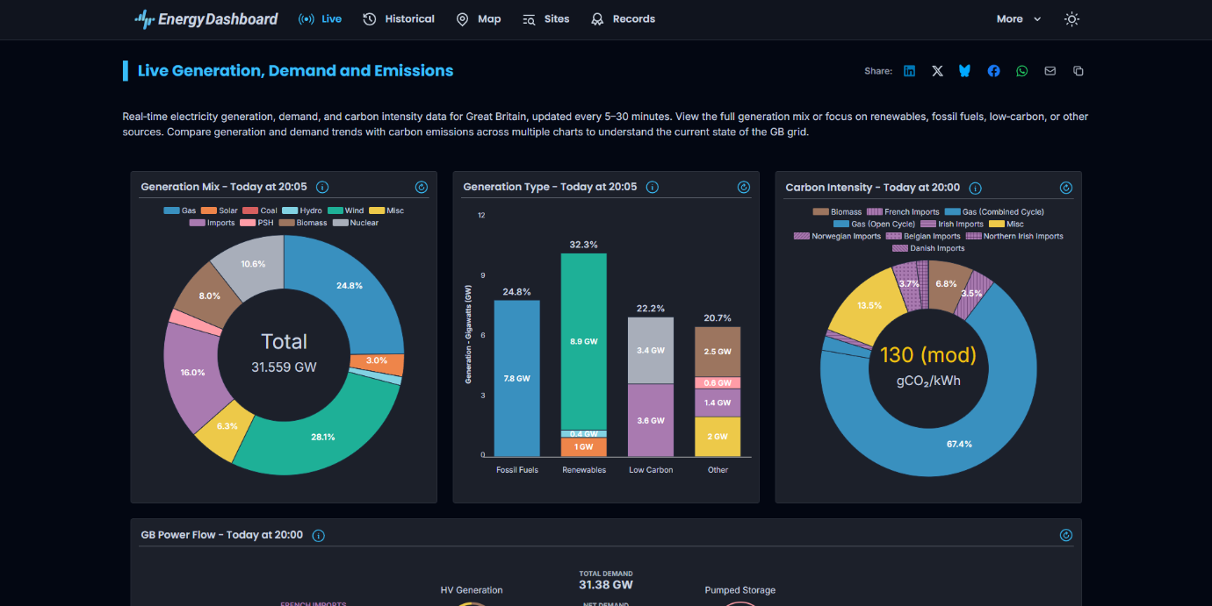
The first site that comes up when we search energy dashboard is “EnergyDashboard”(EnergyDashboard.com). it has simple I that is clean and minimalistic. Opting to show the audience rather than tell them, with its bright colours and simple design, it is easy to read. It has 5 pages, live historical, map, sites and records Aswell as an option to switch from light mode to dark mode.
grid.iamkate.com
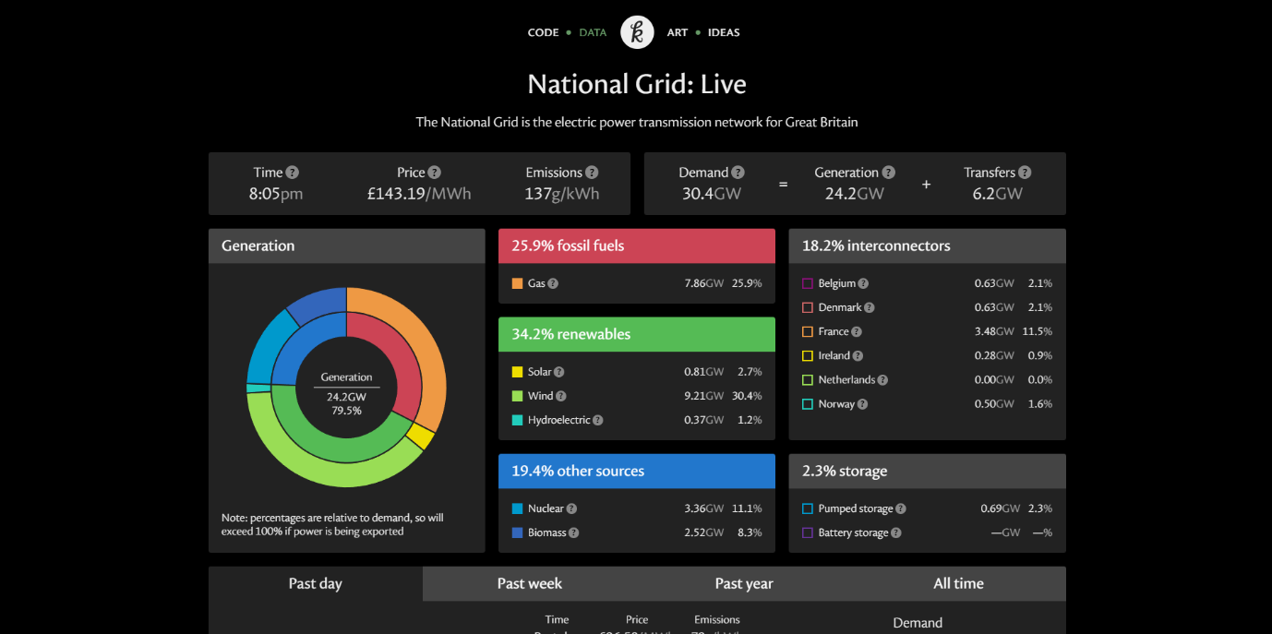
this design was created my Kate Morley that shows data visually through graphs and bright colours against a darker background. It has 4 pages but the sites lack many essential pages and data. Leaning into its minimalistic approach
MyGridGB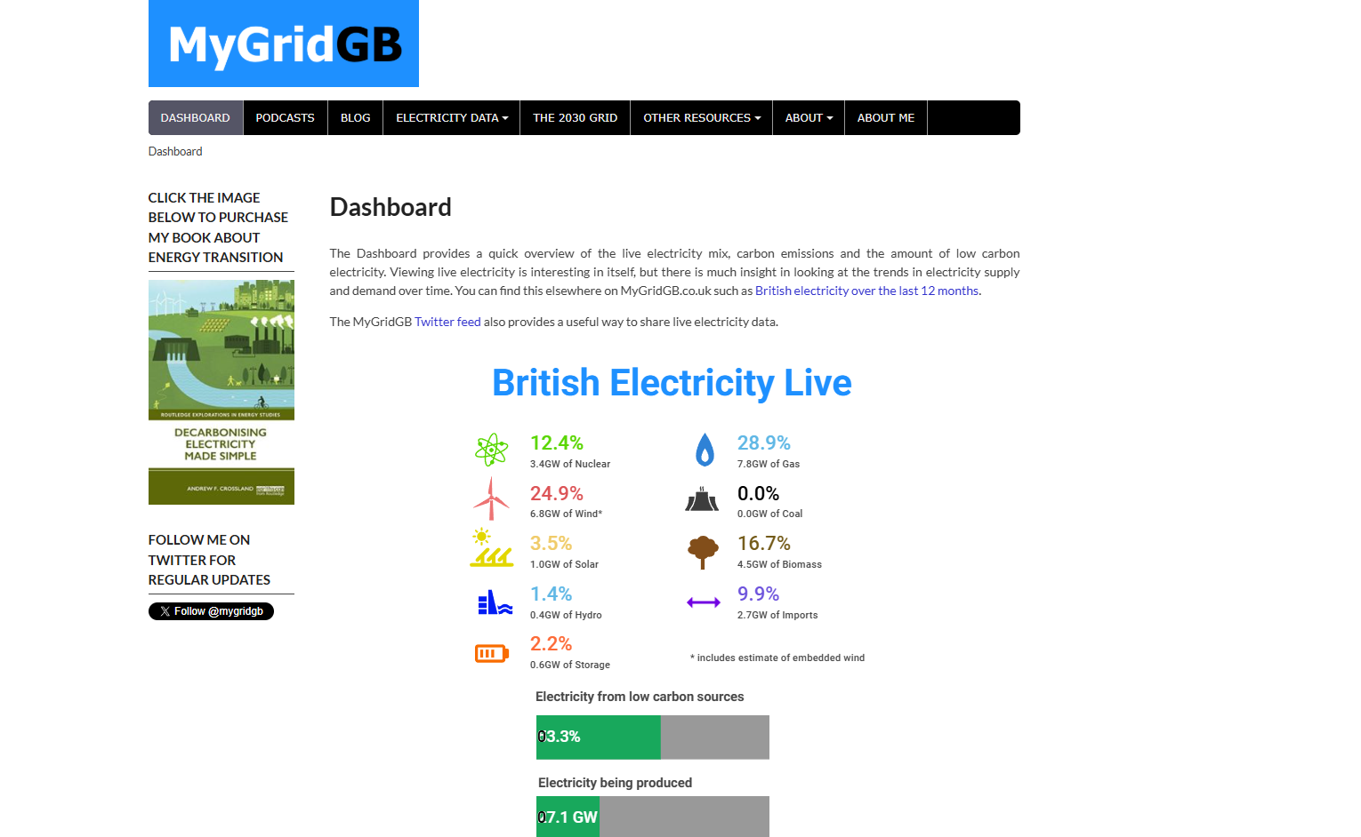
MyGridGB uses less graphs and more writing but still maintains that colourful scheme to present its data. It has 8 pages from dashboard to the about me page. Has bright colours against white background and lacks any logo
Questions for employer
Applicant | question | EnergyDashboard | Grid.iamkate | MYgridDB
1 | What is your favourite feature.
2 | Does it convey the information.
3 | Is it easy too navigate.
4 | Does ut give you all the information you need.
5 | Anything you would add or remove
6 | Black or white or both

